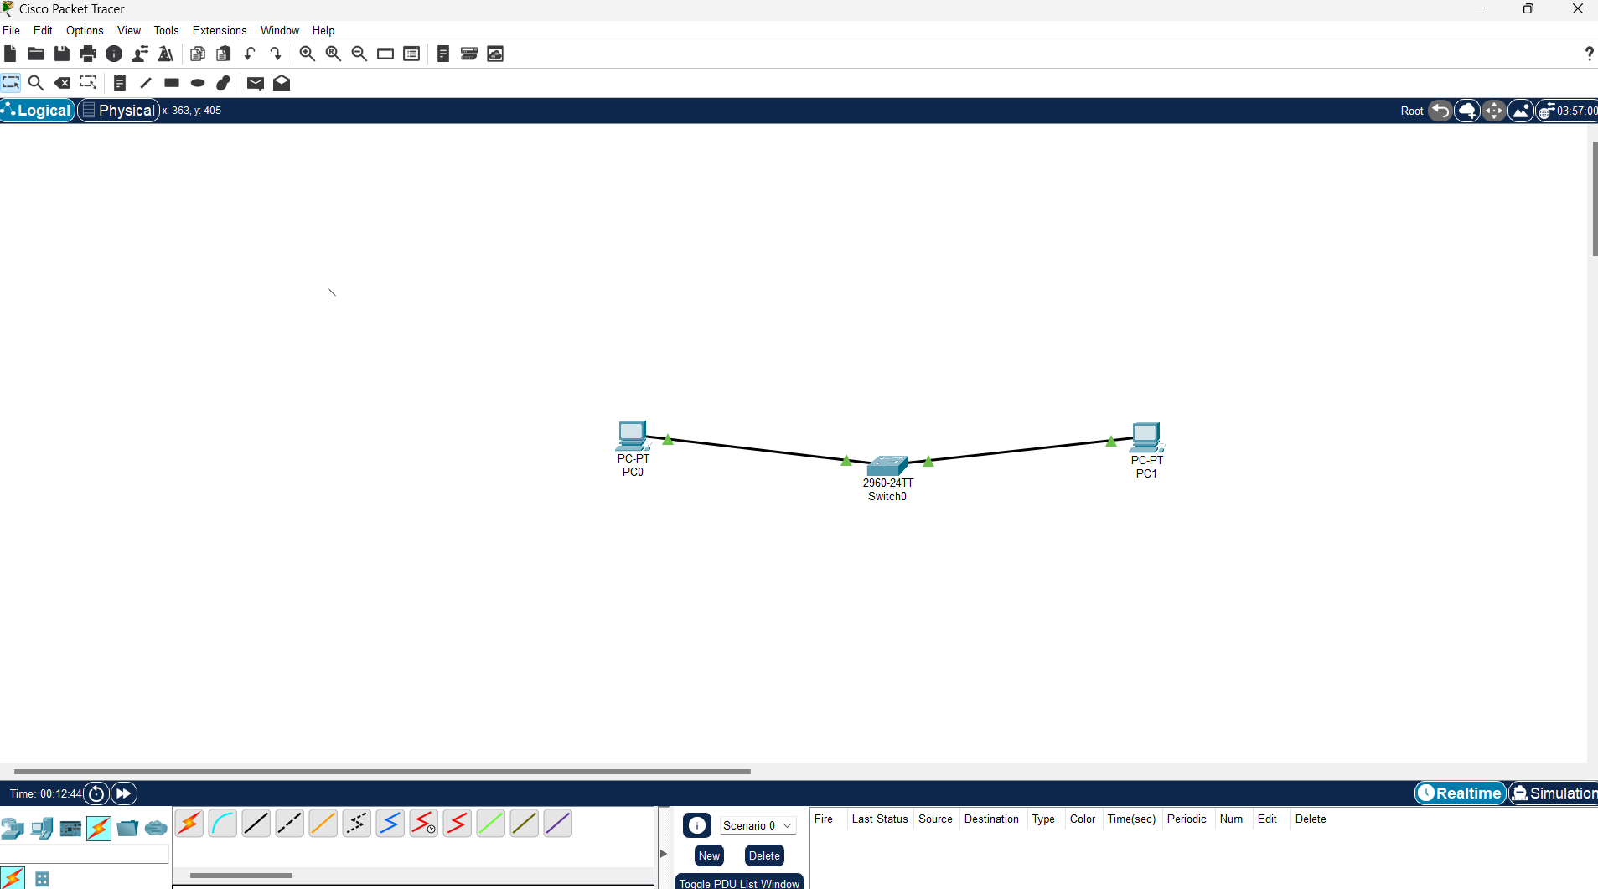

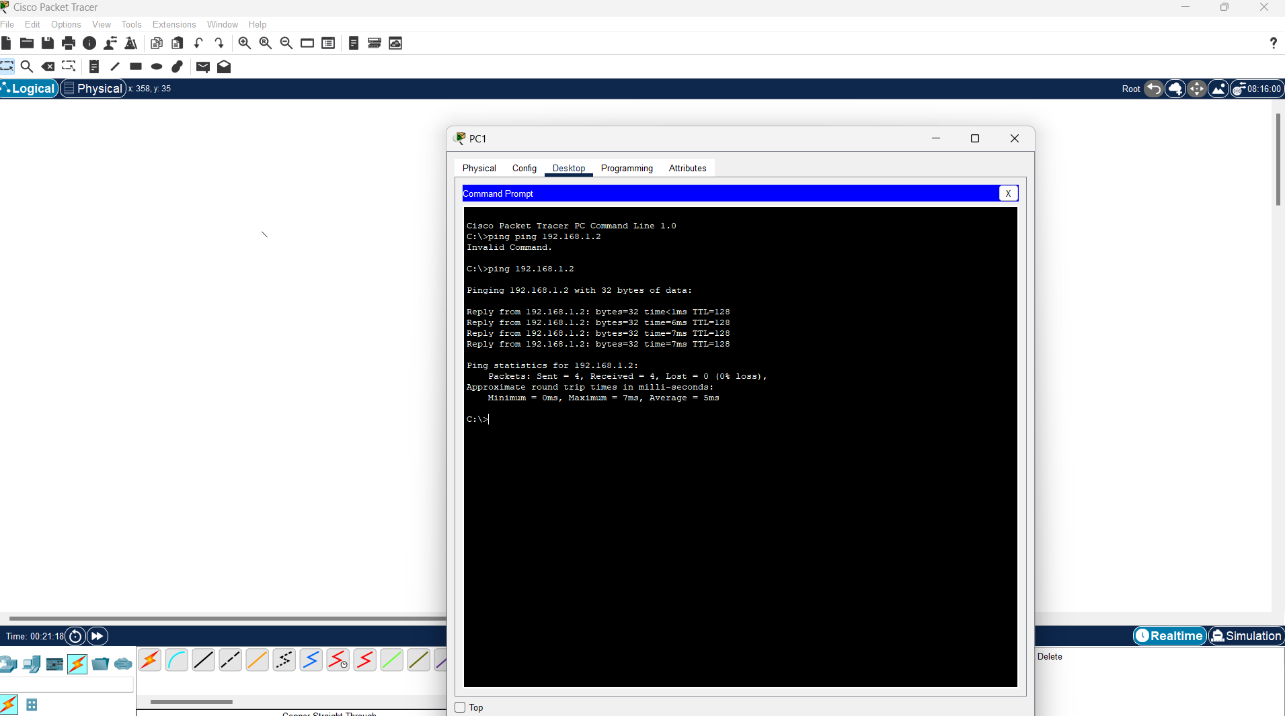

Study of Network Cables and Color Codes

* Research and document the different types of network cables used in computer networking (e.g., copper straight-through, copper crossover, fiber optic cables).
* Document the standard color codes for copper straight-through and crossover cables.

Certainly! The standard color codes for copper straight-through and crossover cables follow the T568A and T568B wiring standards. Here are the details for each:

**T568A Wiring Standard**

1. White/Green
2. Green
3. White/Orange
4. Blue
5. White/Blue
6. Orange
7. White/Brown
8. Brown

**T568B Wiring Standard**

1. White/Orange
2. Orange
3. White/Green
4. Blue
5. White/Blue
6. Green
7. White/Brown
8. Brown

**Straight-Through Cable**

For a straight-through cable, both ends of the cable are wired using the same standard, either T568A or T568B.

**T568A to T568A (Straight-Through)**

mathematica

Copy code

Pin Wire Color (T568A)

1 White/Green

2 Green

3 White/Orange

4 Blue

5 White/Blue

6 Orange

7 White/Brown

8 Brown

**T568B to T568B (Straight-Through)**

mathematica

Copy code

Pin Wire Color (T568B)

1 White/Orange

2 Orange

3 White/Green

4 Blue

5 White/Blue

6 Green

7 White/Brown

8 Brown

**Crossover Cable**

For a crossover cable, one end is wired using the T568A standard and the other end using the T568B standard. This configuration allows the transmit and receive pairs to be crossed.

**T568A to T568B (Crossover)**

mathematica

Copy code

Pin Wire Color (T568A) Pin Wire Color (T568B)

1 White/Green 1 White/Orange

2 Green 2 Orange

3 White/Orange 3 White/Green

4 Blue 4 Blue

5 White/Blue 5 White/Blue

6 Orange 6 Green

7 White/Brown 7 White/Brown

8 Brown 8 Brown

**Summary**

* **Straight-Through Cable:** Both ends use the same wiring standard (T568A to T568A or T568B to T568B).
* **Crossover Cable:** One end uses T568A and the other end uses T568B.

These color codes ensure proper wiring and connectivity for Ethernet networks, maintaining the integrity and performance of the connections.

4o

* Explain the purpose of each type of cable and where they are used in a network.

**Straight-Through Cable**

**Purpose:**

* Used to connect different types of devices within a network.

**Usage:**

* **Computer to Switch/Hub:** Typically used to connect a computer or a server to a switch or hub.
* **Router to Switch/Hub:** Connects a router to a switch or hub to facilitate network communication.

**Example:**

* Connecting a desktop computer to a network switch to access the network and internet.

**Crossover Cable**

**Purpose:**

* Used to connect similar types of devices directly without the need for a switch or hub.

**Usage:**

* **Computer to Computer:** Directly connects two computers without using a switch.
* **Switch to Switch/Hub:** Connects two switches or hubs directly.
* **Router to Router:** Used for directly connecting two routers.

**Example:**

* Connecting two laptops directly to transfer files without a network intermediary.

**Shielded Twisted Pair (STP) Cable**

**Purpose:**

* Used in environments with high electromagnetic interference (EMI) to prevent signal degradation.

**Usage:**

* **Industrial Environments:** Where machinery or other equipment may generate a lot of EMI.
* **Data Centers:** To ensure signal integrity amidst numerous electronic devices.

**Example:**

* Connecting network devices in a factory setting where heavy machinery might interfere with signals.

**Unshielded Twisted Pair (UTP) Cable**

**Purpose:**

* Most commonly used in general networking due to its flexibility, cost-effectiveness, and ease of installation.

**Usage:**

* **Office Networks:** Connecting computers, printers, and other devices to a central switch or router.
* **Home Networks:** Connecting a router to various home devices like computers, smart TVs, and gaming consoles.

**Example:**

* Setting up a home office network where devices need to connect to the internet through a router.

**Single-Mode Fiber (SMF) Cable**

**Purpose:**

* Used for long-distance, high-speed data transmission with minimal signal loss.

**Usage:**

* **Telecommunications:** Connecting long-distance telecommunications lines.
* **Internet Backbone:** Providing the infrastructure for internet service providers to transmit data over long distances.

**Example:**

* Connecting different cities' data centers for an internet service provider.

**Multi-Mode Fiber (MMF) Cable**

**Purpose:**

* Used for shorter distance, high-speed data transmission typically within buildings.

**Usage:**

* **Campus Networks:** Connecting different buildings within a campus.
* **Data Centers:** Connecting servers and storage devices within the same data center.

**Example:**

* Setting up a university campus network where multiple buildings need to be connected at high speeds.

**Coaxial Cable**

**Purpose:**

* Used for specific types of network setups, particularly where traditional broadband or cable TV services are required.

**Usage:**

* **Cable Television:** Delivering cable TV signals to homes and businesses.
* **Older Ethernet Networks:** Used in some older Ethernet network setups (e.g., 10Base2, 10Base5).

**Example:**

* Connecting a home to a cable TV service provider.

**Summary**

| **Cable Type** | **Purpose** | **Common Usage** | **Example** |
| --- | --- | --- | --- |
| **Straight-Through** | Connecting different devices | Computer to Switch, Router to Switch | Desktop to network switch |
| **Crossover** | Directly connecting similar devices | Computer to Computer, Switch to Switch | Laptop to laptop for direct file transfer |
| **STP** | Reducing interference in high-EMI environments | Industrial environments, data centers | Network devices in a factory |
| **UTP** | General networking with flexibility and cost-effectiveness | Office networks, home networks | Home office network setup |
| **Single-Mode Fiber** | Long-distance, high-speed data transmission | Telecommunications, internet backbone | Connecting data centers between cities |
| **Multi-Mode Fiber** | Shorter distance, high-speed data transmission | Campus networks, data centers | University campus network |
| **Coaxial** | Specific network setups (e.g., broadband, cable TV) | Cable TV, older Ethernet networks | Home cable TV connection |

Each type of cable serves a specific role in network infrastructure, chosen based on the requirements for distance, speed, environment, and type of devices being connected.

4o

Certainly! Here’s a detailed overview of the different types of network cables used in computer networking:

**1. Copper Cables**

Copper cables are the most common type of network cable used in computer networking. They come in different configurations based on their intended use.

**a. Straight-Through Cable**

* **Use:** Connects different types of devices, such as a computer to a switch or a router.
* **Wiring:** Both ends follow the same wiring standard (e.g., T568A or T568B).
* **Pin Configuration:** Pin 1 to Pin 1, Pin 2 to Pin 2, and so on.

**b. Crossover Cable**

* **Use:** Connects similar devices directly, such as computer-to-computer or switch-to-switch.
* **Wiring:** One end follows T568A, and the other end follows T568B.
* **Pin Configuration:** Pins 1 and 3 are crossed, as well as pins 2 and 6.

**c. Shielded Twisted Pair (STP)**

* **Use:** Reduces electromagnetic interference (EMI) and crosstalk.
* **Construction:** Contains shielding (foil or braided) around pairs of wires.
* **Common Types:** CAT5e STP, CAT6 STP.

**d. Unshielded Twisted Pair (UTP)**

* **Use:** Common in most networking environments due to its flexibility and lower cost.
* **Construction:** Lacks additional shielding around the wire pairs.
* **Common Types:** CAT5e, CAT6, CAT6a, CAT7.

**2. Fiber Optic Cables**

Fiber optic cables are used for high-speed data transmission over longer distances. They use light to transmit data, which provides several advantages over copper cables.

**a. Single-Mode Fiber (SMF)**

* **Use:** Long-distance communication.
* **Core Diameter:** Smaller core (8-10 microns).
* **Light Source:** Laser.
* **Advantages:** Low signal loss, high bandwidth, suitable for long distances.

**b. Multi-Mode Fiber (MMF)**

* **Use:** Shorter distances, typically within buildings.
* **Core Diameter:** Larger core (50-62.5 microns).
* **Light Source:** LED.
* **Advantages:** Easier to install, lower cost, suitable for shorter distances.

**3. Coaxial Cables**

Coaxial cables are used in specific types of network setups and are characterized by their layered construction.

* **Use:** Traditional broadband, cable TV, and some older Ethernet networks.
* **Construction:** Consists of a central conductor, insulating layer, metallic shield, and outer insulating layer.
* **Common Types:** RG-6, RG-59.

**Comparison and Summary**

| **Cable Type** | **Typical Use** | **Advantages** | **Disadvantages** |
| --- | --- | --- | --- |
| **Straight-Through Copper** | Different devices (e.g., PC to switch) | Standard for most connections | Limited distance |
| **Crossover Copper** | Similar devices (e.g., PC to PC) | Direct device connection | Less common |
| **STP Copper** | Environments with high EMI | Reduces interference | More expensive |
| **UTP Copper** | General networking | Flexible, cost-effective | Susceptible to EMI |
| **Single-Mode Fiber** | Long-distance, high-speed | High bandwidth, low signal loss | Expensive, complex installation |
| **Multi-Mode Fiber** | Short-distance, high-speed | Easier installation, lower cost | Limited distance |
| **Coaxial** | Cable TV, older networks | Good for specific applications | Bulky, less flexible |

These different types of network cables each serve specific purposes, and choosing the right type depends on the requirements of the network in terms of distance, speed, and environment.